WORLD VISION ETHIOPIA
WASH PROGAM

Brief report on
Barrier analysis(BA) and Design for Behavior Change Frame Work (DBC) For
Targeted mothers of children under five years old clean all drinking water storage containers at least once per week on Chittu, Duele kori and Weldo telfam Kebele
BY: Eyob Legesse and Kebede Tessema
9/3/2015

Table of Contents
Background 2
2. Statement of the problems 3
3. Methodology 3-4
4. Discussion, analysis and interpretation of results ………………………………………………………… 5-6

5. Plan and schedule for operation the activities…………………………………………… 7

6. Annex………………………………………………………………………………………… 8

1. Background
Wonchi Woreda: - is located in South West Showa Zone of Oromia Regional State. The Woreda has a population of 136,493 people of whom 68,929 are males and the rest 67,564 are females. It is located at 123 Kilometers Southwest of Addis Ababa. The total area of the woreda is 457.5 sq km. It has a total of 24 Kebele Administrations (KA The smallest administrative unit in Ethiopia), out of which 56% is midland area and 44% is the highland. The average family size is 5.
Woldo Telfam kebele is one of the operation areas of Wonchi AP. It is located 15 km in North West Wonchi woreda, with a total population of 7000(1,400 households) out of which 3430 are males and the rest, 3,570 are females. The number of households, which constructed latrine, are 1400, which is 100%. And currently in the kebele there is no open defecation practice and the households of the kebele latrine utilize the constructed latrine with local hand washing facility.
Dulele Kori is one of the operation areas of Wonchi AP and It is located 18 km in the eastern part of the district of Wonchi from wolisso town and it is with a total population of 5750(1150 households) out of which 2820 are males and 2925 are females, the number of households which constructed latrine 1030 and previously the kebele was open defecation free in addition households with latrine utilize their latrine. And Chitu is one of the operation areas of Wonchi AP and It is the town of Wonchi district and the town is with a total population of 2395(479 households) out of which 1173are males and 1222 are females, the number of households which constructed latrine 400 and households with latrine utilize their latrine but there is also an open defecation practice.

2. Statement of the problems
Health related problems of the Wordae are: Shortage of quality health services, prevalence of contagious disease, Diseases such as are malaria, diarrhea, unknown fever, Lung/ upper respiratory disease like pneumonia, Intestinal parasites or helmentiasis, Gastritis, and skin disease etc prevail in the area, inadequate health facilities associated with unavailability and un affordability of drugs and Communicable, epidemic and water born diseases due to poor personal as well as environmental sanitation and shortage of potable water were some of the problems of the district in previous years.
To fill this gap identified on sustainable behavior change the DBC frame have been conducted on different behavior in different target areas of the districet as we all know that sustainable behavior change is mandatory, thus seven day Barrier analysis (BA) and Design for Behavior Change frame work(DBC) survey on behavior of Targeted mothers of children under five years old clean all drinking water storage containers at least once per week on Chittu, Duele kori and Weldo telfam Kebele was carried out for 45 doers and 45 non doers.

3. Methodology
- In order to conduct this BA analysis the following methods were followed. Selection of behavior and formulation of the behavior statement, the priority group description and the Barrier survey questionnaire were done in consultation with East Africa Regional Office and WV Ethiopia WaSH Division S and H Coordinator for Ormia region. Ethical and local administration clearance from woreda health office and implementation planed schedule were completed by Wonchi Worda.
- The questionnaire was prepared originally in English and it was translated into Afaan Oromo for the subjects and in the end, the English version of the questionnaire was attached in the annex I. Relevant comments were incorporated after pretest have done at the time of orientation and consulting with trained and experienced data collectors. For assurance of data quality the data collectors were recruited carefully and trained for one day and proper coding and supervision were conducted.
Data coding, data tabulation were conducted daily basis BA tabulation of results Excel spreadsheet with standard graphics were done using a computer.
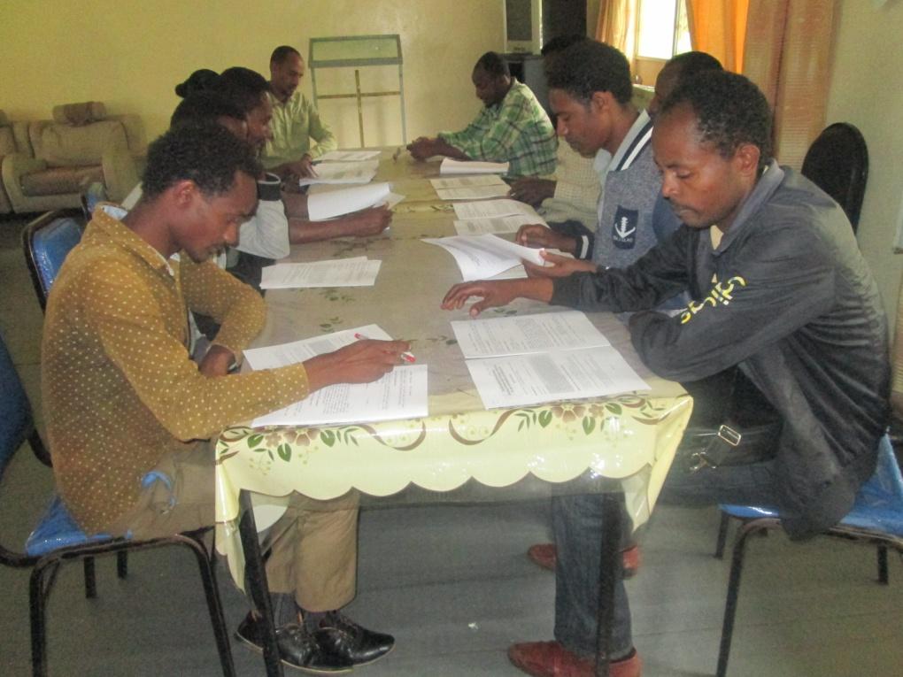
Figure 1 Venue during date collectors training or Orientation, Wonchi WVE Hall, July, 2015
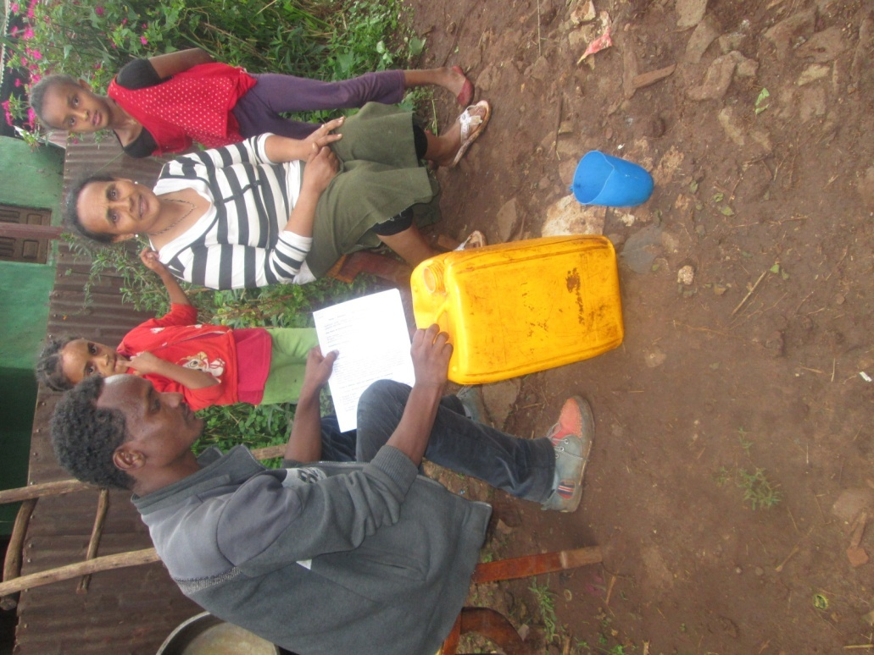
Figure 2 Enumerators observing the status of water storage and during data collection, Chittu, July, 2015

4. Discussion, analysis and interpretation of results

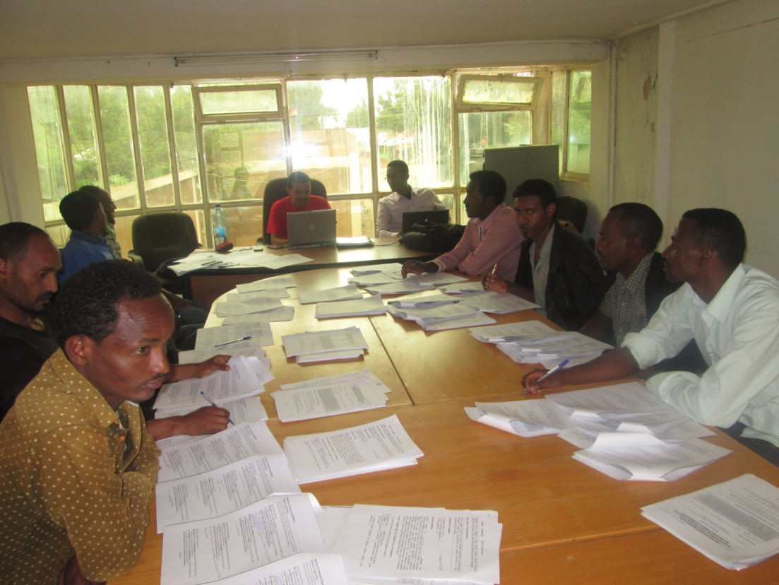
Figure 3 Data tallying and submission for interpretation and analysis, Wolisso, July, 2015
Computer were used in analysis of the results and determinant that have significant difference greater than 15% or P value less than 0.05 and determinant that are action able were considered as significant. Based on this the bridges to activities and activities were formulated.
From the survey the following determinant are significant and bridges to activities and the activities were designed. The determinants were
- Perceived Self Efficacy
- Perceived social norms
- Perceived positive consequence
- Action Efficacy, Perceived Severity Perceived Susceptibility
- Cues for action.
For the detailed information about the identified determinants please see the DBC frame work and BA Table.
Below is some of the graph, which shows cues for action, which have percentage difference of more than 15%
.

Graph shows the percentage of mother clean their water container for doers and non-doers, on Chitu, Dulele-Kori and Weldo Telfam, kebeles of the Wonchi district.
5. Plan and schedule for operation the activities
The plan and schedule in which the activities will implemented is in FY -16 starting from quarter one up to quarter four. The head office will give supportive supervision and follow up on the developed activities to be conducted, In addition to this separate regular reporting in quarter basis will expected from the ADP.

ANNEX1- Barrier Analysis Questionnaire-

Dear Frenesh here below please paste the developed BA questionnaires of mothers with under five children!

Designing for Behavior Change Framework – Mothers with under five children clean water storage container, Wonchi District
Behavior | Priority Group | Determinants | Bridges to activities | Activities
Targeted mothers of children under five years old clean all drinking water storage containers at least once per week | 1.Demographic  - Mothers of 15-49 years with under five children  - Low in come  - Low educational level or literacy  - Some read and write Amharic & Afan Oromo  - Speak Afan Oromo and Amharic  - Live on high and mid land, hilly and mountainous area  - Urban and Rural area of Wonchi district  - Chittu, Dulele kori, and Weldo telfam kebeles  - All are Orthodox and Pentecostal Christians  2.What they do/Daily activities  - Cleaning and looking forward to their children  - Cleaning a house  - Farming and helping their husbands  - Helping and fulfilling family needs(Cocking)  - Going to church on every Sunday  - Selling “Enset” or False Banana  - Go to market every Wednesday and Saturday  - Coffee and tea ceremony in the morning  - Do not practice cleaning their water storage once per week  - Listen to the radio every day  3.Common Desires  - To have access to basic infrastructure  - To have a healthy, productive and good life  - They want to see the success of their children  - To have and build a well furnished house  - To be wealthy  4.Barriers to the behavior  - Lack of supporter in home and sufficient time  - In ability to get and afford soap and jerry cans due to high cost and not available in markets  - Families or friends do not approve in order to save water  - Low level of awareness and education on the link between cleaning of water storage and prevention of diseases(healthy life) and also it is not a priority  - It is very difficult to remember to clean water storage containers.  - Using may become source of respiratory diseases.  - Lack of knowledge how to clean  5.Know, Feels, Practices @ behavior  - They are aware of the link between cleaning water storage container and diarrhea or water borne disease prevention but feels that cleaning water storage is extra burden to buy a soap and wastage of water plus time consuming.  6. Stage of Change  - Knowledge stage | - Perceived Self Efficacy  - The desire to prevent algae, bad smell, re-contamination and water borne diseases makes it easier to clean water containers at least once in a week  - Having an awareness and knowledge about cleaning and understanding once own obligation makes it easier to clean a water storage container at least once in a week  - Fear of susceptibility plus the need to be clean and neat through improving the hygiene and sanitation status my family makes it easier to clean a water container at least once in a week  - Lack of supporter in home makes it difficult to clean a water container at least once in a week  - Lack of time makes it difficult to clean water container at least once in a week.  - Lack of available materials makes it difficult to clean water container at least once in a week.  - Perceived positive Consequences  - Cleaning water storage containers at least once in a week avoids worrying, susceptibility through increasing satisfaction and feeling of clean and neat plus makes us to be healthy  - Perceived social norms  - Family (Husband, children, father and neighbors) approves cleaning of water storage containers at least once in a week.  - Perceived access  - Access to materials needed for cleaning water storage container storage resulted in practicing the desired behavior.  - Cues for action  - It is very difficult to remember when to clean water storage containers in a week at least once.  - Perceived Severity  - It is very serious if children got diarrhea as a result of not cleaning water storage container at least once in a week | - Increase the perception that cleaning water container will prevent bad smell, algae, risk of re contamination and water borne diseases  - Increase the perception that having awareness, and knowledge plus understanding once own obligation will make it simple cleaning of water storage container (This bridge can be achieved by the other activities)  - Increase the perception that cleaning water storage will avoid fear of susceptibility from getting diseases plus will improve the sanitation and hygiene status of a family  - Increase the perception that cleaning water storage container is not an extra burden or time consuming  - Increase the perception that family support and approve of cleaning water storage container  - Increase the perception that materials needed for cleaning water storage container are affordable and available.  - Increase the ability to remember to clean water storage container at least once in a week  - Reinforce the perception that not cleaning water storage container will be very serious to children they will got a diarrhea  - Increase the perception that child will not got diarrhea if the water storage container cleaned at least once in a week | - Organizing mothers with under five children on a tea and coffee ceremony in order to improve their knowledge, understanding and practice to ward cleaning of water storage container twice in a month.  - Conduct a simple and unforgettable demonstration on how to clean a drinking water storage container  - Selecting and identifying mothers with best understanding and practice from organized mothers for coffee ceremony  - Preparing a sign or a bill board using a photo of model mother practicing of cleaning water storage container which is to be posted in a targeted mothers living area  - Recognize, praise and reward model mothers who clean water storage containers in households at once in a week in a public forum or events.  - Give health education on the importance of cleaning water storage container in the prevention of bad smell, algae production, re-contamination and water borne diseases plus its importance on improve sanitation and hygiene practice and health  - Capacitate Families on the importance of cleaning water storage container so as to stop the perception of wasting water and extra burden  - Establish family support group composed of husbands, friends, children and neighbors in order to encourage mothers cleaning of water storage container  - Capacitate local private actors or merchants on cleaning water storage container to increase the availability of soap, and jerry cans in the market places  - Establish artisans, which can produce and sell materials needed for cleaning water storage container  - Make a periodic awareness rising program regarding to clean water storage container at least once in a week.  - Print broachers and colored picture about cleaning water storage container to be posted at each mothers home  - Implement all, monitor and report back to organized mothers at a time of coffee and tea on cleaning water storage container.
Outcome Indicator:  % of mothers with under five children who clean their water storage containers at least once per week |  |  | Process Indicators:  # of organized Mothers groups for coffee and tea ceremony  # of posters developed and placed around living areas.  # of mothers who report having seen the posters and knowing the key message  # of Billboards developed and placed around villages in the Kebele.  # of mothers participated on the coffee and tea Ceremony.  # of demonstration conducted on how to clean a water storage container  # of recognitions conducted for model mothers.  # of artisans established and privates capacitated  # of family support group established and capacitated.  # of broachers printed and distributed.  # of periodic awareness risings conducted.

Place for the questionnaires

